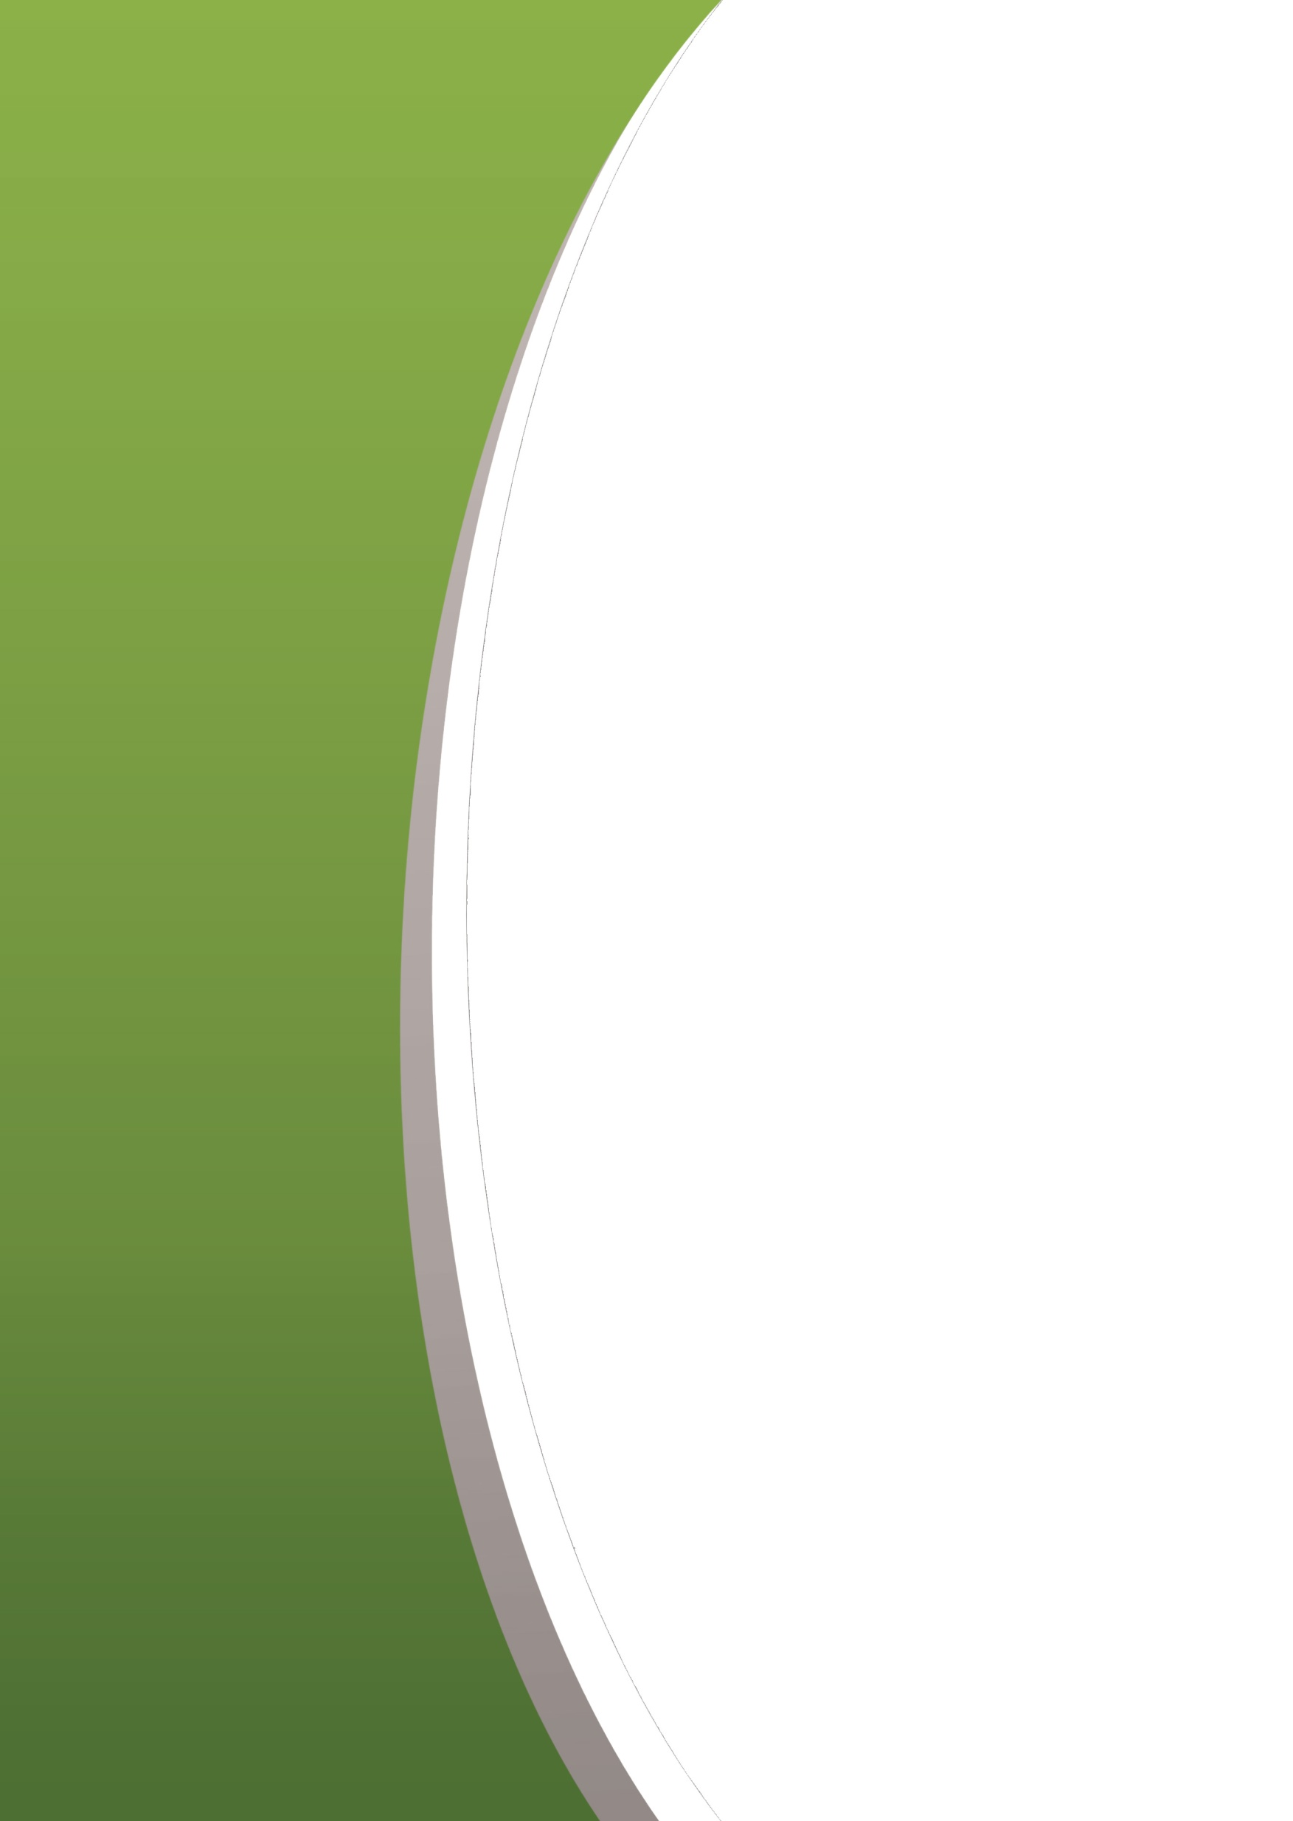

Prepared by:

**Gerber Technology**

**YuniquePLM**

**Material Folder**

**The Raw Material Folder**

“Materials” is a general term in YuniquePLMTM used to describe all the elements that are necessary to make up a style. Materials in YuniquePLMTM are items such as fabric, buttons, etc.

All materials in YuniquePLMTM are stored in the *Raw* *Material Folder*. *Raw* *Material Folder* items used in the development of styles in YuniquePLMTM are simply links to the original items stored in the *Raw* *Material Folder*.

**Accessing the Raw Material Folder**

To access the Raw Material Folder click on icon with the same name.

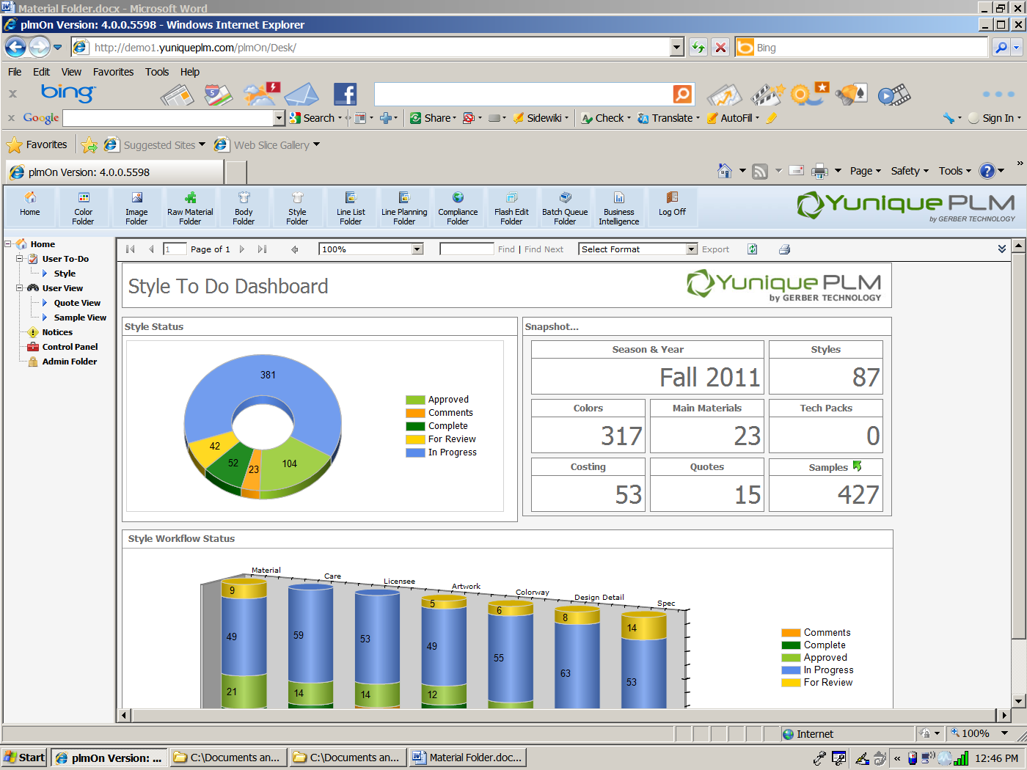

The material folder will open in a new window. Material types will be displayed on the left side of the window. This list is configurable to company needs. There is no limit to the number of material types that can be established. Each material type can have specific property information associated with it, such as yarn type for a knit or ligne size for buttons. User permissions within the Material Folder can be set according to the various material types available. On the right side of the window the individual material items will be displayed. The search fields across the top of the material items assist with faster searching by entering the appropriate data. The green arrows across the top of the window will help to navigate page by page. The display can be set to show as few as five material items per page and as many as fifty.

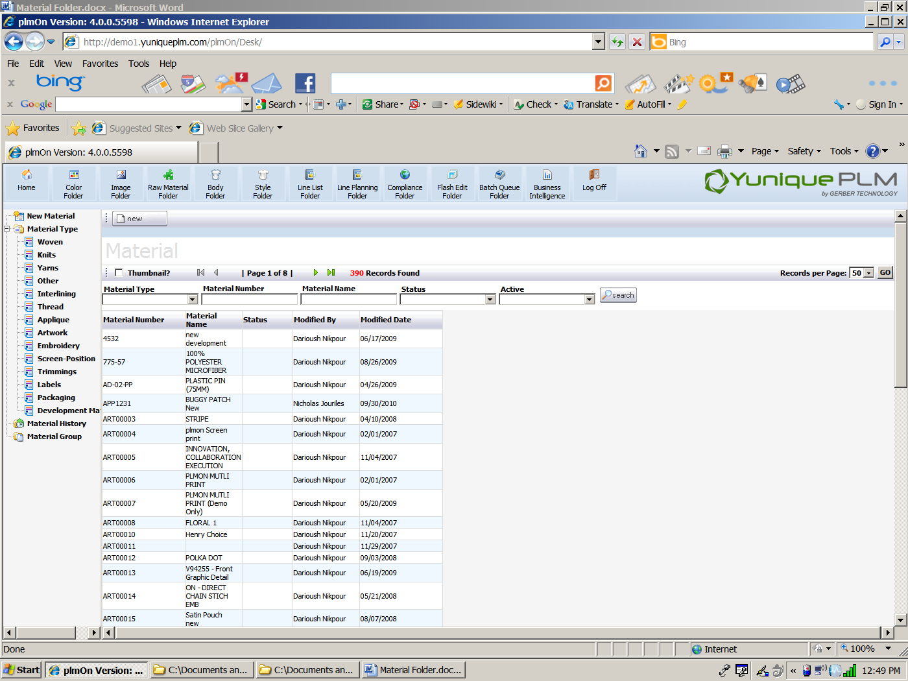

**NOTE:** All search fields are configurable and therefore may be different than those shown in this document.

When a specific Material Type is highlighted on the left, the list of material items on the right changes to reflect the selection, and the properties across the top of the list also change. These properties are configured to be more specific to the material type. More details related to each material item will be displayed across each row when a specific Material Type is selected.

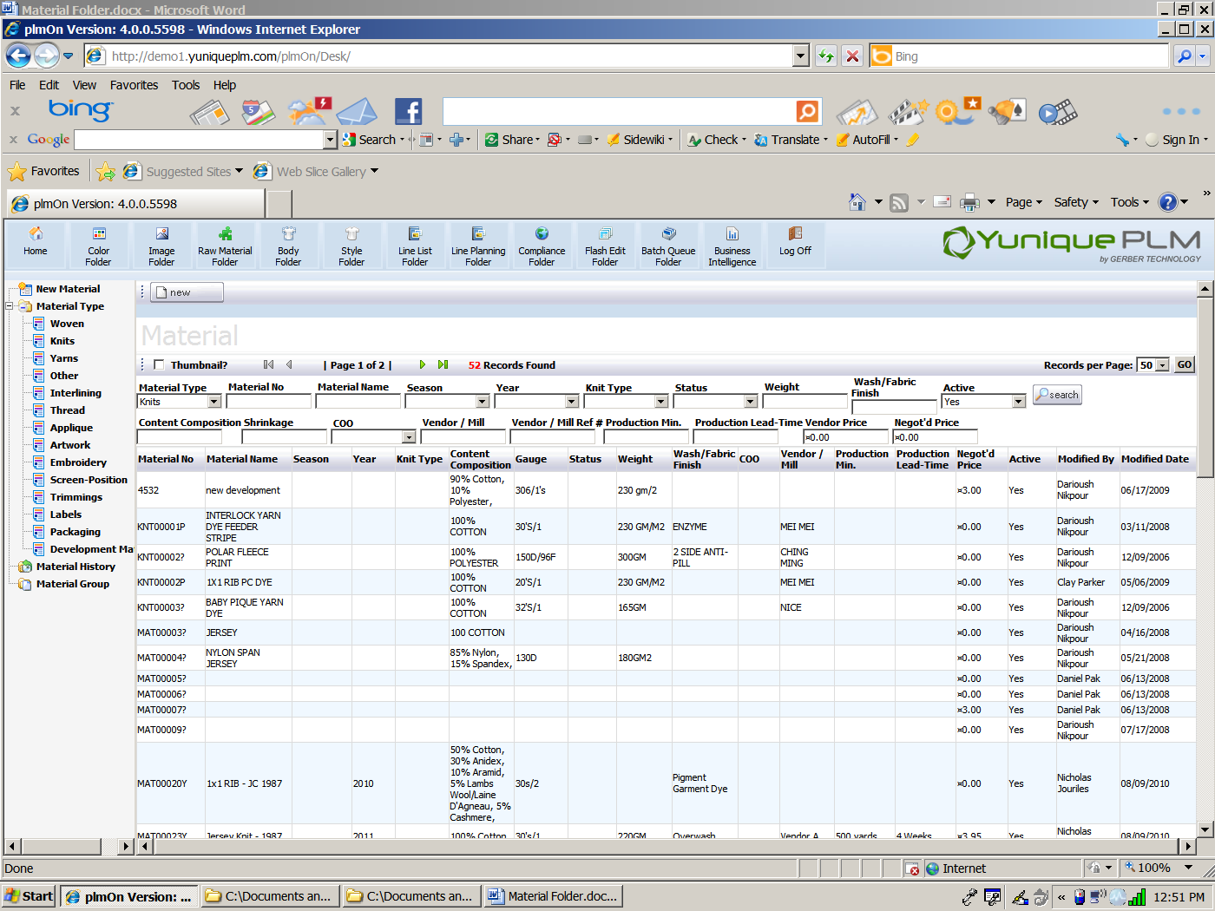

When data is entered into the search fields the system will filter the list based on that information.

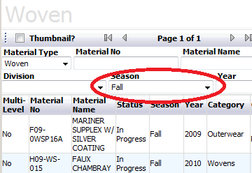

On the left side of the window is a Material History list. This will display the most recently viewed/edited material items for each individual user. This will allow easier access to items being used or developed at that moment.

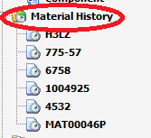

**Adding a New Material Item**

To add a new material item to the Material Folder click on the New button across the top of the window or click on the New Material node on the left side of the window.

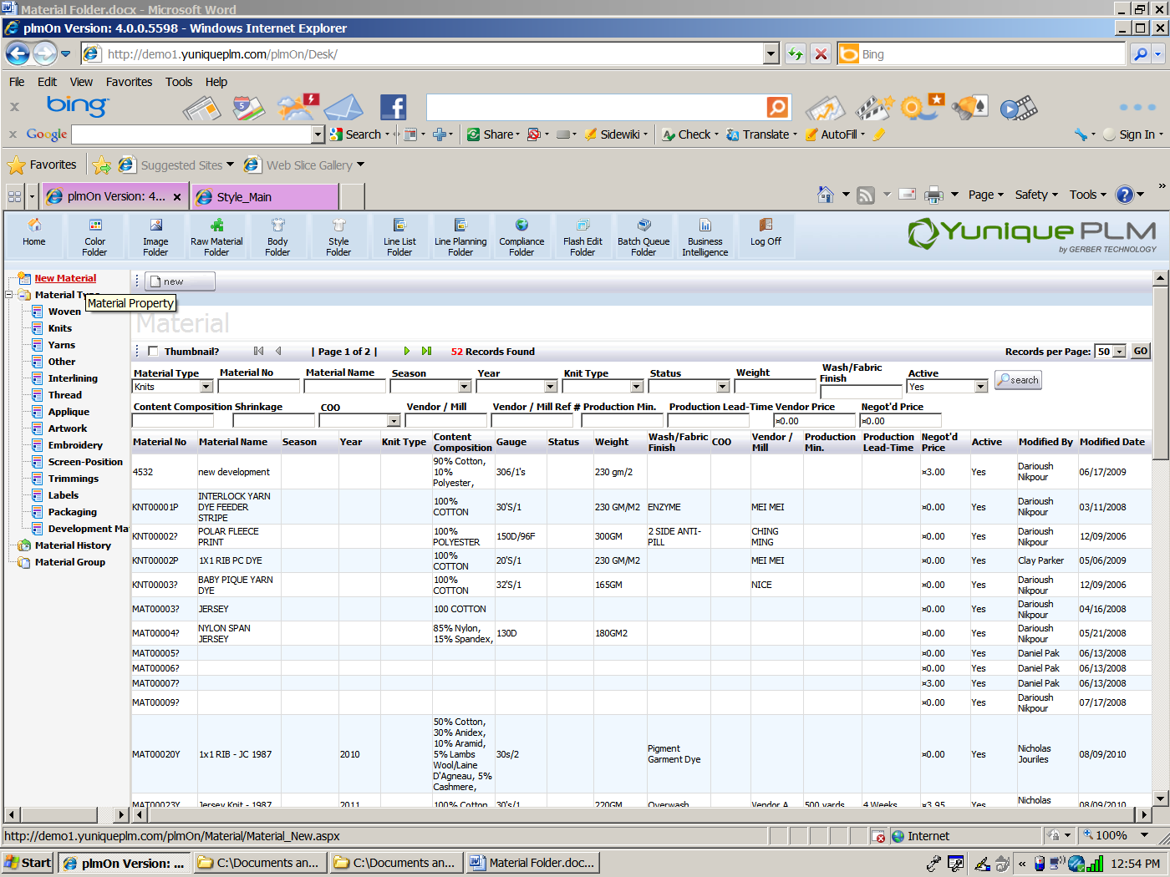

Next select the material type for the new item being added.

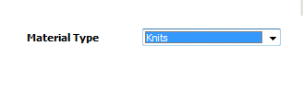

Fill in the appropriate information for the properties of the new material item being added and click the next button across the top of the screen.

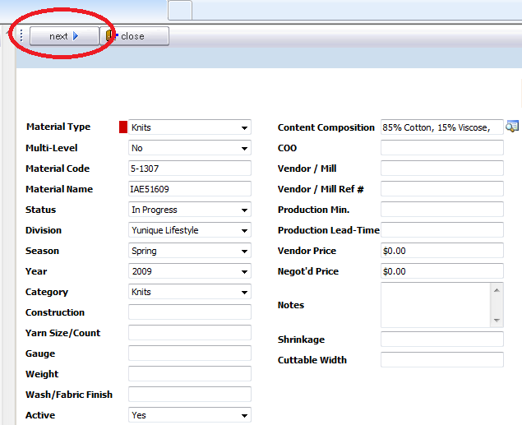

Once the new material record has been saved, additional information can be added to the record. An image can be added, as well as color information.

**NOTE:** All material property fields are configurable and therefore may be different than those shown in this document.

**Adding a Material Image**

YuniquePLM ™ allows for each material item added within the Material Folder to have a main image associated with it. Additional images in the form of color chips or file attachments can also be added, but the main image should be the best representation of the item for communication purposes.

There are a few options available for associating an image to a material item. One way is to link to an image that has already been added to the Image Folder. To do this click on the Image node on the left side of the material item window.

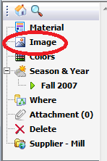

Then choose the Imaged Type on the right side of the material folder window.

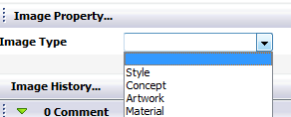

Once the image type is selected the File Type can be selected and data can be entered into the image property fields. The properties will be specific to the image type selected.

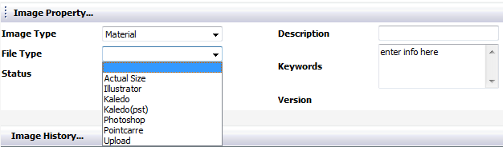

Once the desired file type is selected and the all other appropriate data entered, the image can be linked to a file that is already in the Image Folder by clicking on the Select Image button across the top of the window.



The data located in the image folder will be displayed on the right side of the window. Information can be entered into the data fields across the top of the window to narrow the search.

**NOTE:** All search fields are configurable and therefore may be different than those shown in this document.

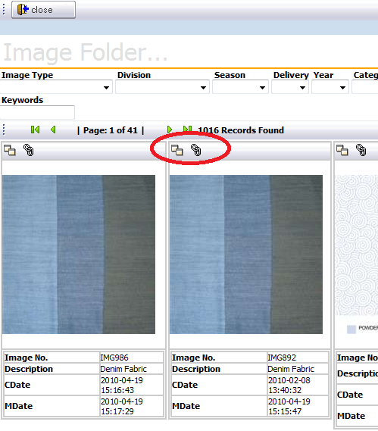

Once the desired image is visible, it can be associated to the material item by selecting the Link icon in the upper left corner of the thumbnail image.

There is also a copy icon in the upper left corner. If Copy is selected then a copy of the selected image will first take place within the image folder. Then the newly copied file must be selected and linked to the material item.

Once linked, the newly associated image will be displayed as a thumbnail on the left side of the material folder window, and in a larger representative in the lower right side of the window.

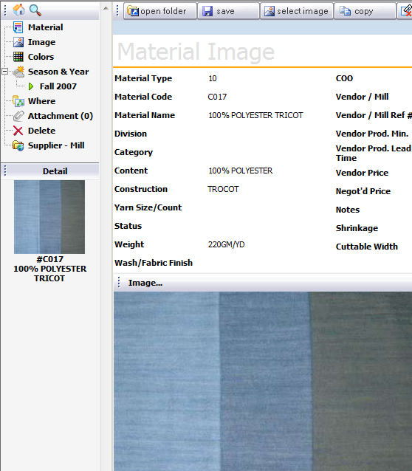

YuniquePLM allows certain image file types to be generated in their native software application, so that images not already in the image folder can also be associated with a material item. To do this, first set the Image Type to Material.

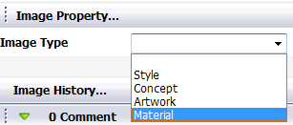

Once the Material Image screen is presented, select the appropriate file type in the Image Properties area and then click on the Create Image button across the top of the window.

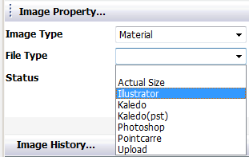

At this point the icons will change across the top of the window. Click on the Open Folder button in order to access the template for the application to be used to generate the new image.

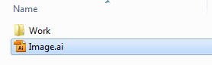

Another option is to import an image that has already been created but that is not already in the image folder. To do this Upload must be selected as the File Type. Once Upload is selected, and Image File input area will be available for browsing to network location of the desired image.

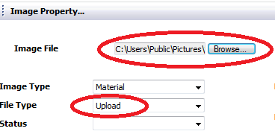

Once the file path is populated in the Image File field, click on the Create Image button across the top of the window in order to save the file and associate it with the new material item.



**Adding Material Colors**

Typically individual material items added to the Material Folder will be available in multiples colors. The color information will need to be added to the material item from the colors within the Color Folder.

To associate specific colors with the material item click on the Add Color button on the right



The system will then require that a specific color palette be selected from the color folder. To select a palette click OK.

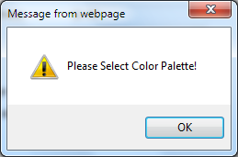

The list of available color palettes will be presented on the right hand side of the window. The palette can be selected by highlighting and clicking on the palette name in the list. The green arrows can be used to scroll to additional pages of available palettes.

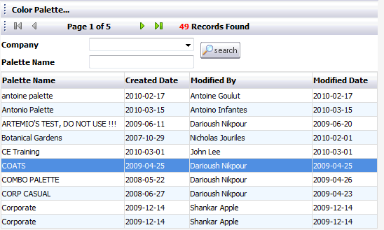

Once the desired color palette is presented, place a check mark in the upper left corner of the color chips to be associated with the new material item. Then click on the save button across the top of the window Colors from multiple palettes can be associated with an individual material item.

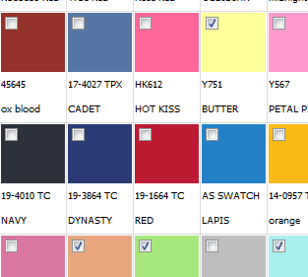

Another way to select colors is by clicking on the Colors node on the left side of the window.

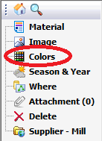

Once the colors screen is presented on the right side of the window click on the Add button.



A separate window will open displaying all available color palettes. The list can be filtered by entering data in the fields across the top. Highlight and click on the desired color palette name from the list.

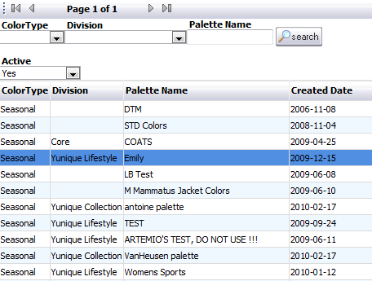

The color chips of the selected palette will be displayed on the left side of the window. To select a color, place a check mark in the upper left corner of each color chip then click the Add button across the top of the window.

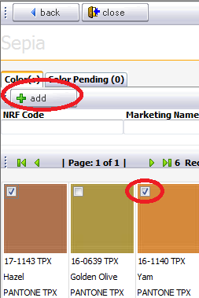

Before the colors are associated with the material item they are placed in a Color Pending area. The colors displayed here must be verified and then added to the material item. To access the Color Pending area click on the tab. Then place a check in the upper left corner of the desired color chips, and choose the Add button across the top of the window.

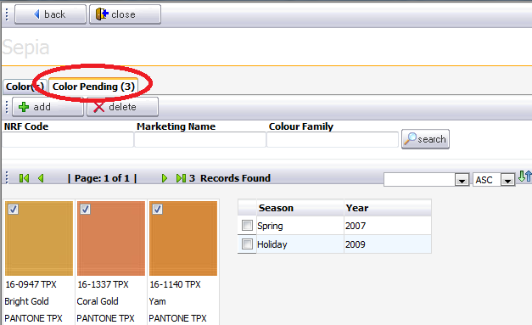

All colors that have been associated with the material item will be displayed on the right side of the window.

To select colors from additional color palettes click on the Back button across the top of the screen. This will present the list of available palettes again.



Once all desired colors have been added to the material item click on the close button across the top of the screen.



**NOTE:** The color palette as well as individual colors must already exist in the color folder before they can be associated with a material item.

An image file can also be associated to a material item to represent a color. This might be done if color swatches were scanned into the system or if the “color” being represented is a print colorway. To associate and image file as a material color click on the Select Image button.



The Image Folder will open in a new window. To choose an image place a check mark in the upper left corner of the thumbnail. Data can be entered in the property fields across the top of the window to filter the images.

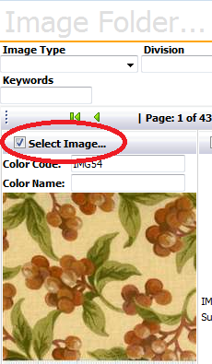

Once all images have been selected click the Save button followed by the Close button across the top of the window.



**Adding Material Dimensions**

Often material items are available with variations other than color associated with them, such as fabric treatment or button size. These variations of an individual material item are known as dimensions. The Material Folder can be administratively managed to allow dimensions to be selected from a preconfigured drop down list or manually entered as needed.

To associate a dimension(s) with a material item manually, select the number of rows to be added and click on the Add button located on the lower right side of the material item window. The number of rows to be added will equal the number of dimension variations. For example if a button is available in 3 sizes, then 3 rows would be added.



A dialog will be presented verifying that a new dimension should be added. Click OK to add the new dimension information or click Cancel to end the process.

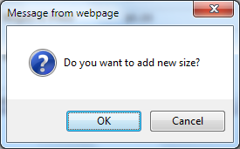

A new row(s) will be displayed in the dimensions area allowing the new information to be entered manually.

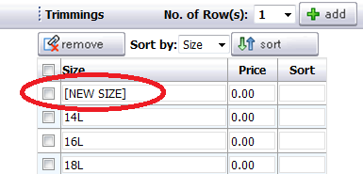

The information can be sorted by the price or the dimension type. This is done by selecting the preference from the drop down list and clicking the Sort button.



The sort order can further be changed by entering a number value representing the preferred row number ordering and then saving the material item by clicking on the save button across the top of the window.

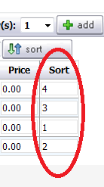

Dimension information can be removed by placing a check mark to the left of the unwanted information and then clicking the remove button.

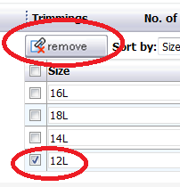

**Making Changes to a Material Item**

Once items in the material folder are used in the development of a style, making changes to that material item’s information may have an effect on the associated styles. By clicking on the Where node on the left side of the material window, all styles that use the material item will be displayed on the right side of the window.

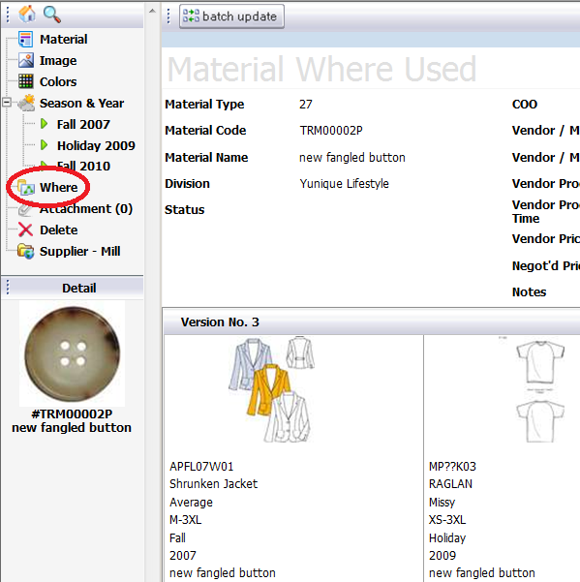

By clicking the Batch Update button across the top of the Material Where Used window, styles can be selected to receive the new information associated with the material item.



Placing a check mark to the right of the style number(s) requiring the new material information and then clicking the Update button across the top of the screen will push the most current information into the styles that will be directly affected.

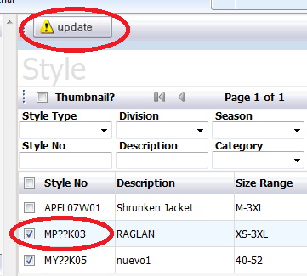

A dialog will be presented for verification of the change. Click OK for the change to take place or click Cancel to end the process.

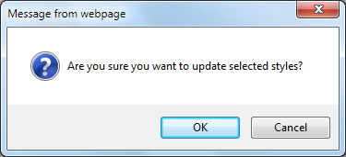

If style(s) are overlooked for any reason when a batch update is performed, an alert will be presented the next time the materials bubble of a style folder utilizing the altered material item is opened. The alert will give a like to update the material item or allow the previous version to remain.



**Deleting Material Items**

Material items can be deleted as long as there are no style folders that have been developed using the material item. To delete a material item, click on the Delete node on the left side of the material item window.

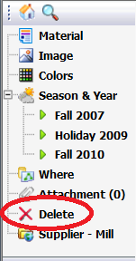

If the material item has been used in the development of a style folder, those styles will be displayed on the right side of the material item window and there will not be a Delete button presented.

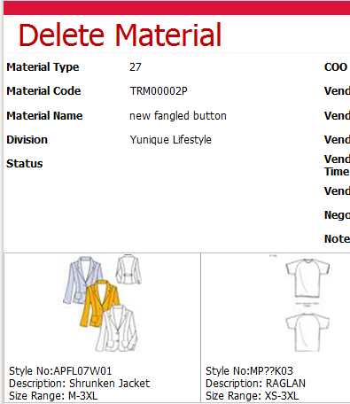

If the material item has not been used in the development of a style then the Delete button will be presented across the top of the window.

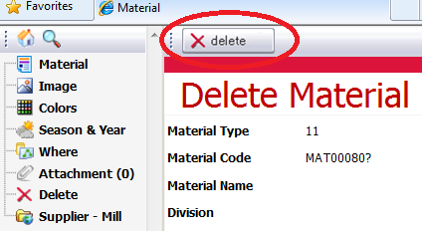

**Adding Attachments to a Material Item**

Additional information in the form of data file(s) can be associated with a material item. Any standard data file type, such as a word document or excel spread sheet, can be stored as an attachment. To do this, click on the Attachment node on the left side of the material item window.

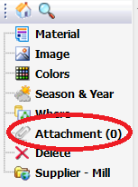

Then click on the New button on the right side of the Attachments window.



Clicking on the Browse button of the File Upload field will launch a standard windows network search. The desired file can then be selected from where ever it is being stored on the network, and the file path will be displayed in the field. A description of the file can be entered in the File Description field on the left. Place a check mark to the right of the Share File with Agent field if agents will have permission to view the file.

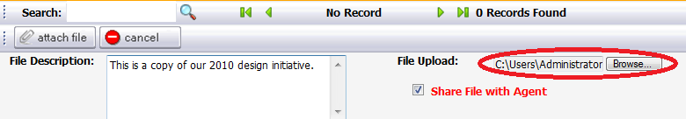

Click on the Attach File button across the top to associate the file with the material item, or click the Cancel button to end the process.

Files will be listed on the right side of the attachments window and the number next to the Attachments nodes will reflect the total number of files associated with the material item once the process is complete.

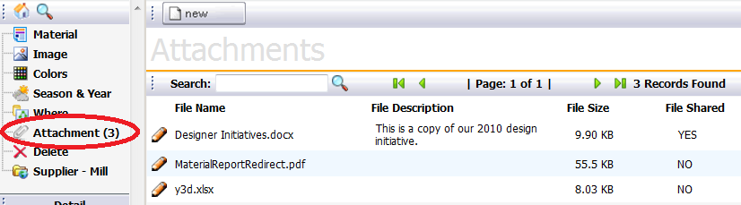

**Adding a Season & Year**

Once a material item has been added to the materials folder, it can be further categorized beyond the general material type. Very often certain material items should be used in the development of styles only during certain seasons. For example, linen fabric may only be used for Spring style development. To associate specific season/year combinations to a material item, click on the Season & Year node on the left side of the material item window.

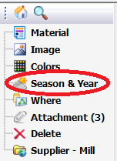

Then click on the Add button across the top of the Season & Year window displayed on the right.



A window will open listing all available season and year combinations. A check mark can be placed in the box to the left of all season/year combinations that will be associated with the material item.

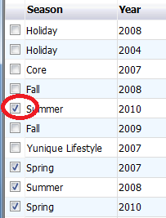

Click on the Add button to confirm the selection, then click on the Close button to complete the process.



The selected season/year combinations will then be displayed when the Season & Year node is expanded on the left side of the window and on the lower right side of the window.

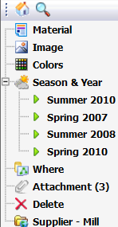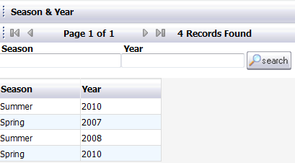

Extensive lists of season/year combinations can be filtered by entering data into the Season Year fields across the top of the list and clicking the Search button.

**NOTE:** Material items must have at least one Season/Year associated with it in order to have the ability to be tracked under the Supplier – Mill node.

In addition, the colors in which a material item is available can be further categorized by season/year. To associate specific colors of a material item to certain seasons, highlight the season on the left side of the material window. Then click the Add button.

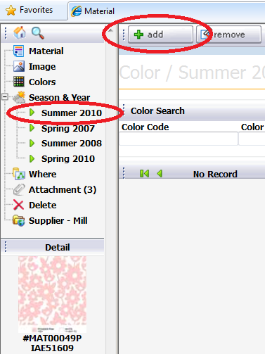

Once the list of available colors is presented, place a check in the box to the left of the colors that should be associated with the select season.

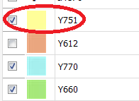

The colors will then be listed on the right side of the window when the related season node is selected in the material item window.

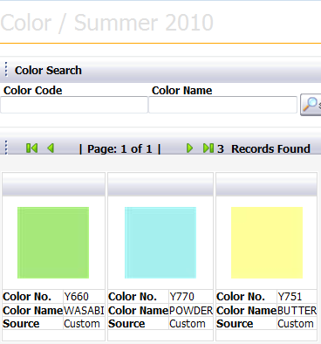

**NOTE:**  Material item colors must have at least one Season/Year associated with it in order to have the ability to be tracked under the Supplier – Mill node.

**Supplier - Mill**

The Supplier – Mill node is available as an area of potential collaboration with overseas agents or venders that would be accessing the data from the Yunique SRM software application. This is where material requests can be generated and continually tracked throughout the process. Material tracking is based on a combination of material season, color and dimension attributes. In order to generate a new request, click on the Supplier – Mill node on the left side of the material item window.

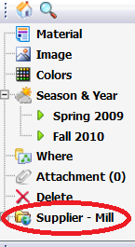

Once the Material Request window is displayed on the right side of the window, click on the New button across the top.



The new request will be based on a dimension(s) of the material item such as fabric color or fabric treatment. The colors associated with the material item will be listed in the Material Request window according to the season/year selected in the drop down list.

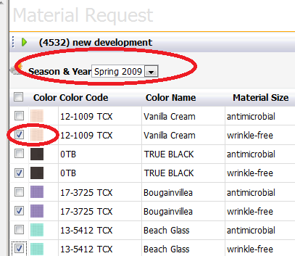

A check mark should be placed in the square to the left of the color chip(s) that need to be tracked. Once all desired color(s) have been selected click on the Next button at the bottom of the window.



A Workflow must be selected from a drop down list based on the material type for which the request is being generated. Each workflow will have specific processes associated with that selection. For example, woven fabric will most likely have different approval processes than knit fabric. Either the start date OR the due date should be entered to begin tracking the request.

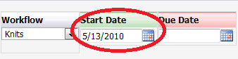

Click the Next button across the bottom of the window.



A list of Agents and Vendors will be displayed. Place a check in the box to the left each vendor that will receiving a request.

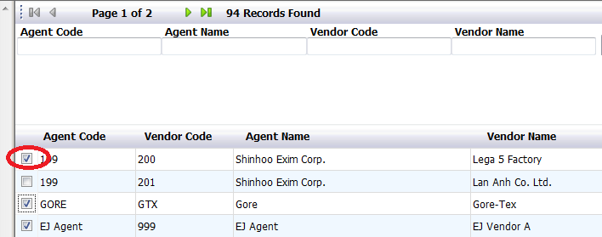

Click the Next button at the bottom of the screen.



The summary of the selected information will be displayed for review. Click the save button across the top of the window to confirm the selected information.

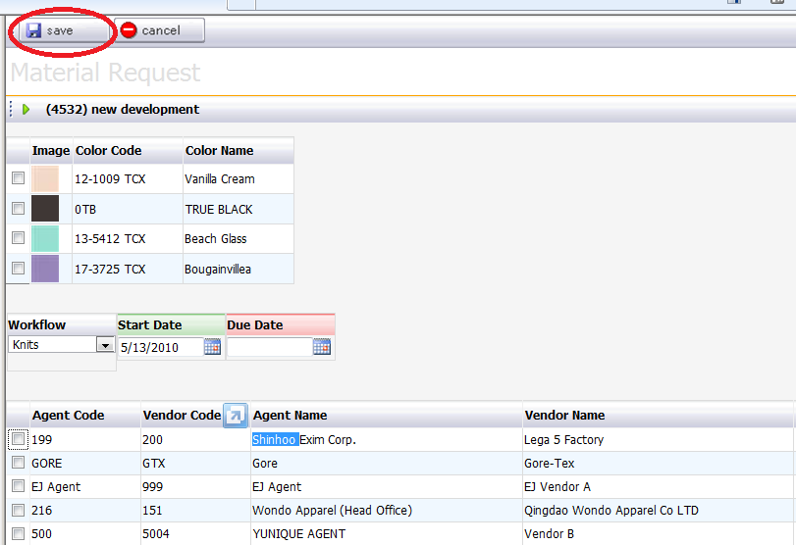

The entire list of outstanding requests will be displayed. Each row represents a request to an individual Agent/Vendor by the color and/or dimension of the material item. Each of the processes that are being tracked for a request will be highlighted yellow across the column header. The requests can be filtered by entering data in the fields located above the list across the top of the window.

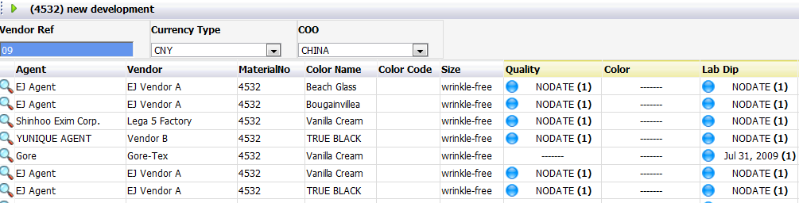

**NOTE:** The workflow list, all processes associated with a workflow, and the data fields for filtering requests are configurable, and may be different than those shown in this documentation.

Home

Lab Dip Tracking

**Packaging and Label**

The Packaging and Label node allows for groupings of packaging and labeling items to be established in order to reduce repetitive actions. Since packaging and labeling items do not often change, and groups of items are commonly used together based on a product type, they can be selected once and then associated with appropriate style folders as needed.

To develop a new grouping, click on the Packaging and Label node on the left side of the material folder window.

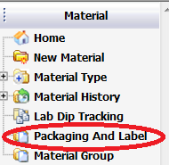

Once the Packaging and Label window is displayed on the right, click on the New button across the top of the window.



The New Packaging/Label Group window will be displayed. All appropriate data should be entered into the fields presented. Then click on the Add button at the top of the window.

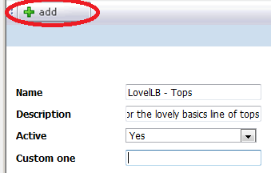

Next the Packaging and Labeling Group window will be displayed. Click on the Add Material button across the top of the window in order to choose material items for the new group.



****************************

**Material Group**

The Material Group node allows for groupings of material items to be established in order to reduce repetitive actions. These groupings can be for product types that are continually repeated season after season. The materials used to develop these styles can be selected once so that they are readily available to be associated with the appropriate style.

**\*\*\*\*\*\*\*\*\*\*\*\*\*\*\*\*\*\*\*\*\*\*\*\*\*\*\***